There are several ways to accomplish cut, copy, delete and paste. But first let’s define these.

Selected text: Text that has been selected by dragging the mouse or manipulating the cursor keys while depressing shift.
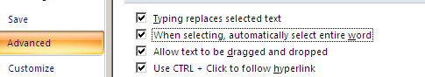
Smart editing: Mouse selection automatically selects entire “word” (Note: changes to this are in word options:

Clipboard: The system component that holds selected data. We looked at this through clipbrd.exe, Below is this line in the clipboard
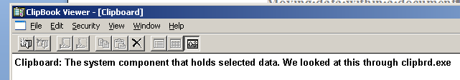
Copy: Copies original text into the clipboard. The original info remains

Cut: Copies original text into the clipboard and then deletes the original

Delete: Deletes the original – no copy into the clipboard

Paste: Retrieves the data in the clipboard and moves it into the document at the cursor.

Ext: (entension) Changes selection criteria of the mouse – to be done later in the class if there is time.
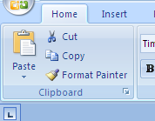
Easiest way of selection is through the home ribbon as indicated to the right. Notice there are four 3 possibilities – Cut, copy, paste in the clipboard section. Click on the bottom control to show what is called the clipbook in Windows. Click on the control with paste and you get the possibility of paste special which is used quite often for copying text from the internet.

Cut and copy are active only because a section of text has been selected. If not text is selected cut and copy are grayed out. Paste and paste special become available because something has previously been put into the clipboard through a prior cut or copy.

Paste will act similar to what we have seen in text boxes. Text is moved to the cursor, but selected text is deleted prior to the paste.

Sometimes paste is not enough. Paste select gives other options. In the case of text (graphics have other options) you may see the following.
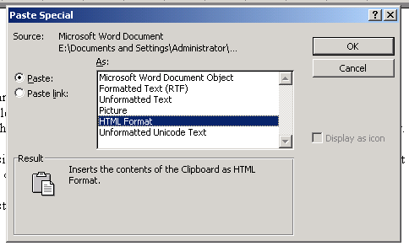The most useful of these is formatted text which allows the user to insert text with the type of formatting that the text contained when cut.

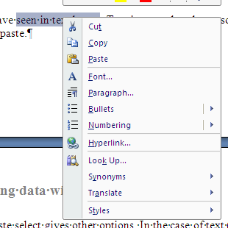
Cut, copy and paste (but not paste select) can be accessed in an easier manner by the use of the right button. Same constaints apply as to selected text. To the right is an example of selected text and the use of the right button.

